**Laboratory Report   
DeVry University  
College of Engineering and Information Sciences**

**Course Number: DBM405A**

**Professor: Lively**

**Laboratory Number:** 5

**Laboratory Title:** Connecting to the Database

**Submittal Date:** 6/2/2015

Note: There is no limit on how much information you will enter under the three topics below. It is important to be clear and complete with your comments. Like a scientist, you are documenting your progress in this week’s lab experiment.

**Objectives:** In your own words, what was this lab designed to accomplish? What was its purpose?

This lab was designed to have us work with views and also introduced us to creating and working with backups of the database. Views help to hide data complexity as well as help achieve data security in a sense by limiting the information that is displayed. This, in addition to working with backing up and restoring data are two key principles in data security practice. The objective of this lab overall was to familiarize us with these data security principles, as they are vital in managing and working with databases, or anything that contains data in an IT field.

**Results:** Discuss the steps you used to complete your lab. Were you successful? What did you learn? What were the results? Explain what you did to accomplish each step. You can include screen shots, code listings, etc. to clearly explain what you did.

Please see the following code/screenshots with comment annotation for each number/step of the lab to see how each step was successfully achieved. Please note each highlighted step, the number of rows affected (for screenshot length purposes), and its ensuing successful output:

#1

create or replace VIEW team_and_players_name

as

select t.tname, p.lastname

from teams t, players p

where t.teamcode = p.team;

select * from team_and_players_name;

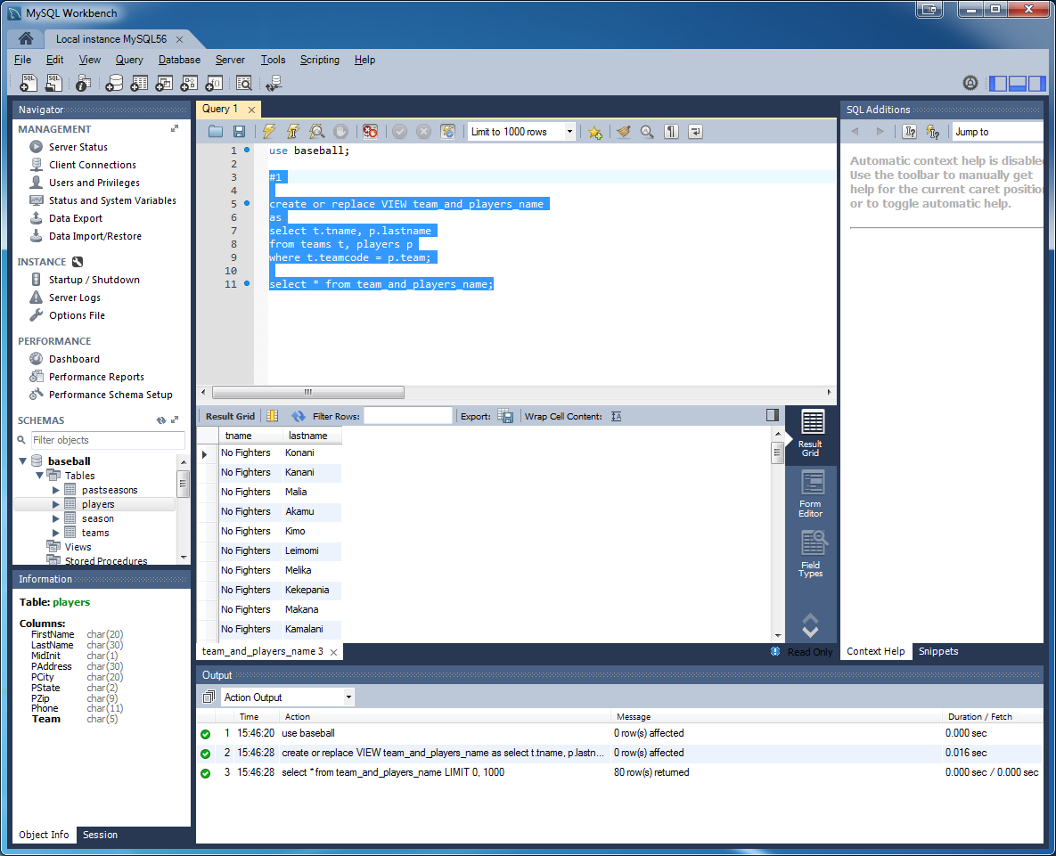

#2

create or replace VIEW current_schedule

as

select hometeam, awayteam, playdate

from season

order by playdate;

select * from current_schedule;

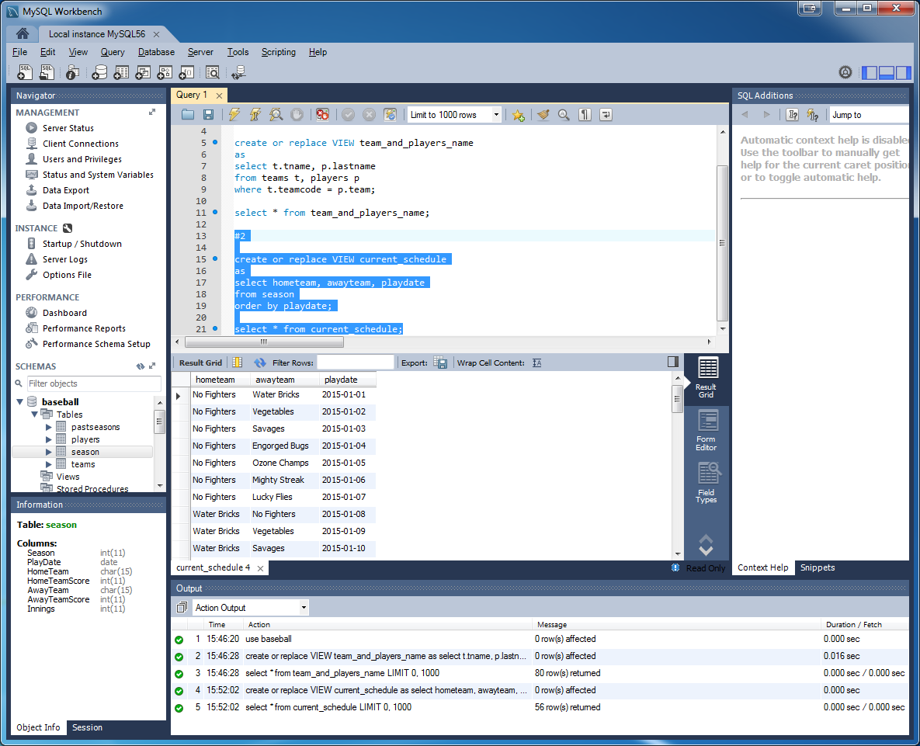

#3

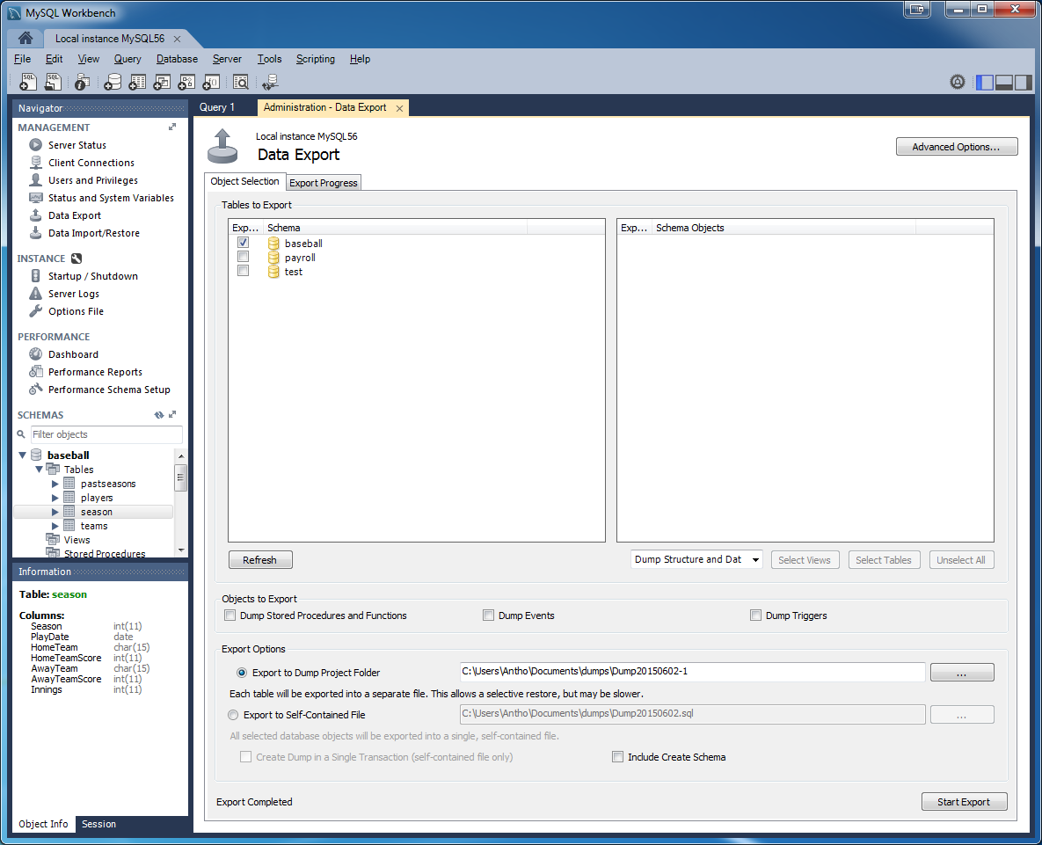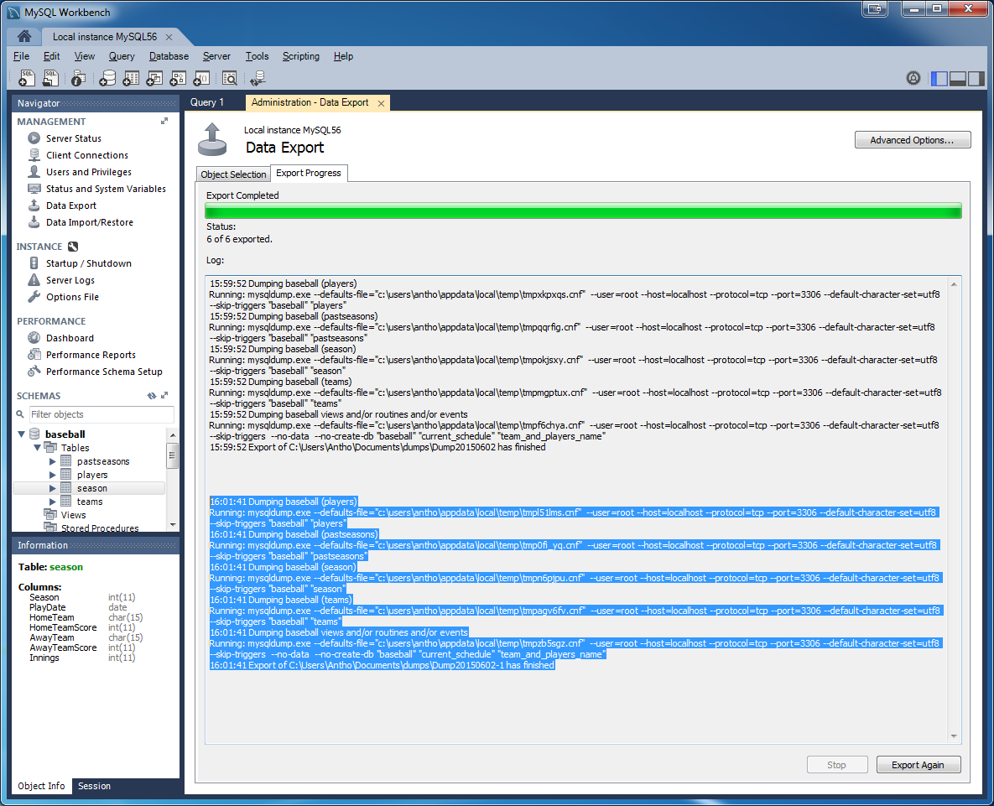

#4

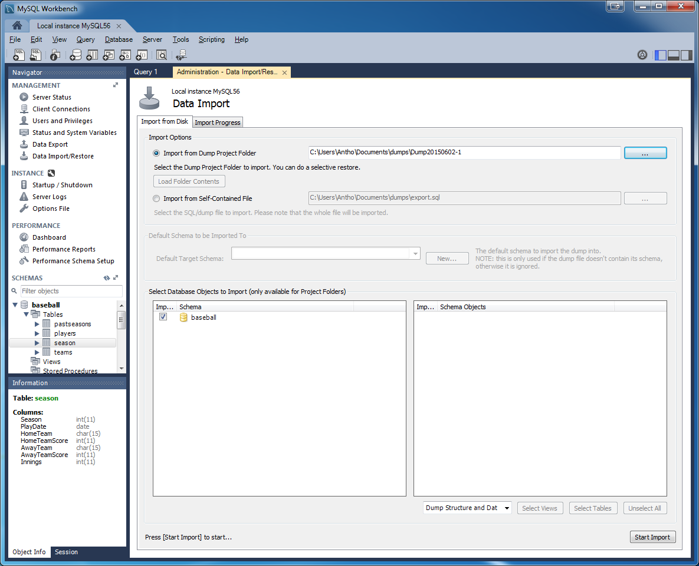

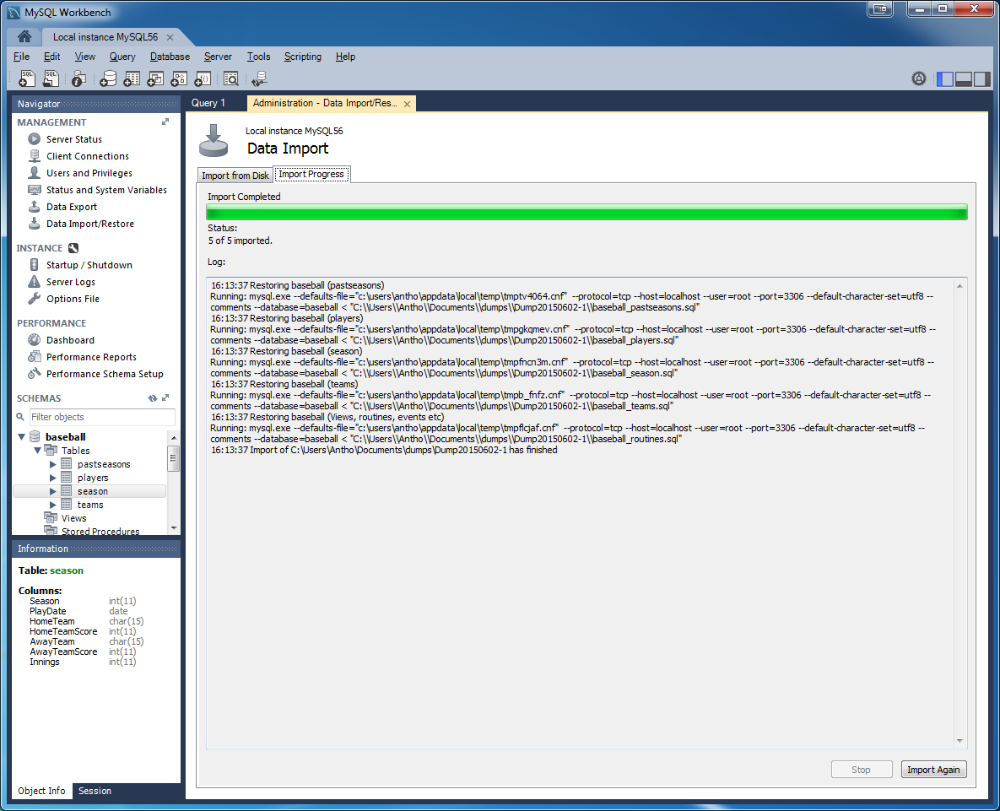

**Conclusions:** After completing this lab, in your own words, what conclusions can you draw from this experience?)

At first when I began working this lab, I did not comprehend the purpose or value of working with views. To me they just seemed like a standard query, as they are organized similarly and share much of the same syntax. However, when you consider the overall purpose of the lab and start considering views with this in mind, you can begin to see how they differ from just a standard query, as they can be created in such a way to only dictated information can be returned. Views seem to be more meant for a user rather than for a developer, as they can restrict access, hide data complexity and simplify queries. In particular the first view (problem 1) was challenging in that it made you exercise a join a statement without directly indicating that anywhere. Only upon selecting * from the view could you see that a Cartesian product was being returned and we needed to isolate what we were searching for. The data export (backup) and import (restore) were pretty self-explanatory in that it was easy to see a file set of the database was being created elsewhere, and then when you restore you are selecting that file set at the external location and importing back into your program to load the database again. This is of course another paramount point in practicing data security when working with a database, or any IT field for that matter. The GUI made it very easy to backup and restore, but the text code format was also included in these results as well for reference if needed.

|  |  |  |  |  |  |
| --- | --- | --- | --- | --- | --- |
| **Student:** | Anthony Meunier |  | CIS |  | Anthony Meunier |
|  | Name |  | Program |  | Signature |